Use Case: Select Criteria to Filter Courses

Brief Description

This use case describes how a student select criteria to filter courses that meet his requirement.

Use-case Diagram

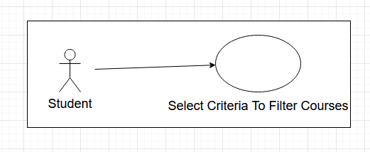

Basic Flow

1. The use case begins when the student actor chooses to select criteria to filter courses that meet his requirements.
2. The system displays the interface for filtering the course

{Begin Selecting a Filter}

1. While student has filter to choose

3.1 Student check(uncheck) any filter that the condition of course should meet.

{End Selecting a Filter}

3.2 The system retrieves and displays the available course information if the course has met given criteria.

1. The use case ends.

Alternative Flows

A1: Select All (De-Select All) Filters

At any point between {Begin Selecting a Filter} and {End Selecting a Filter} if the student has the option to select-all (De-select all) in system.

1. Student can select all (De-select all) of the filter at once.
2. The option of select all (De-select all) changes to De-select all (Select all)
3. The flow of events is resumed at {End Selecting a Filter}